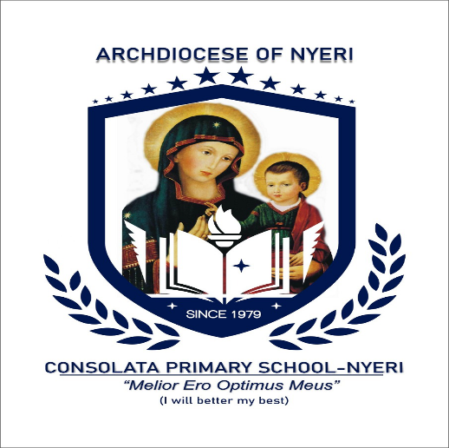

ARCHDIOCESE OF NYERI

CONSOLATA SCHOOL

(PRIMARY & JS)

USER DOCUMENTATION FOR CONSOLATA SCHOOL (PRIMARY AND JS) NYERI WEBSITE

Table of Contents

Identification 3

**Functionality Overview** 3

*Program Title* 3

*Author* 3

*Date Written* 3

*Language Used* 3

*Version* 3

Genaral Specification & User information 4

**1.0 Getting started** 4

*1.1 Introduction* 4

*1.2 Welcome* 4

*1.3 The Navigation Panel* 5

*How To* 21

# Identification

## Functionality Overview

### Program Title

Consolata School Nyeri website

The following functionality is available in the Consolata School Nyeri Website:

1. Access to general information by the public regarding the school, such as events.
2. Access to school specific information including newsletters, fee structures and official communications from the school.
3. Uploading additional learning materials and assistance.
4. View and download additional learning materials such as notes, examinations, recorded lessons, reference materials and assignments.
5. View or Download images or videos.
6. View or download school documents such as fee structure.
7. Call or leave a message for customer support.
8. Subscribe to newletters and other information.
9. Personal corporate email for all staff. E.g. staff@consolataschoolnyeri.org.

### Author

Denis Muthee King’ori

### Date Written

2nd October 2023

### Language Used

HTML, CSS, Bootstrap, JavaScript, Msql, and PHP.

### Version

CSW Version 102023.1

# Genaral Specification & User information

## 1.0 Getting started

### 1.1 Introduction

According to the Wikipedia, a Webiste is a collection of related web pages and related content that is identified by a common domain nmae and published on at least one web server.

Websites are typically dedicated to a single purpose. The purpose of our website is education.

### 1.2 Welcome

Welcome to Consolata School (Primary & Junior Secondary School).

To access the website on the intermet:

1. Click, https//:www.consolataschoolnyeri.ac.ke, or
2. Open your browser and search consolata school nyeri.

You should land on the page below.

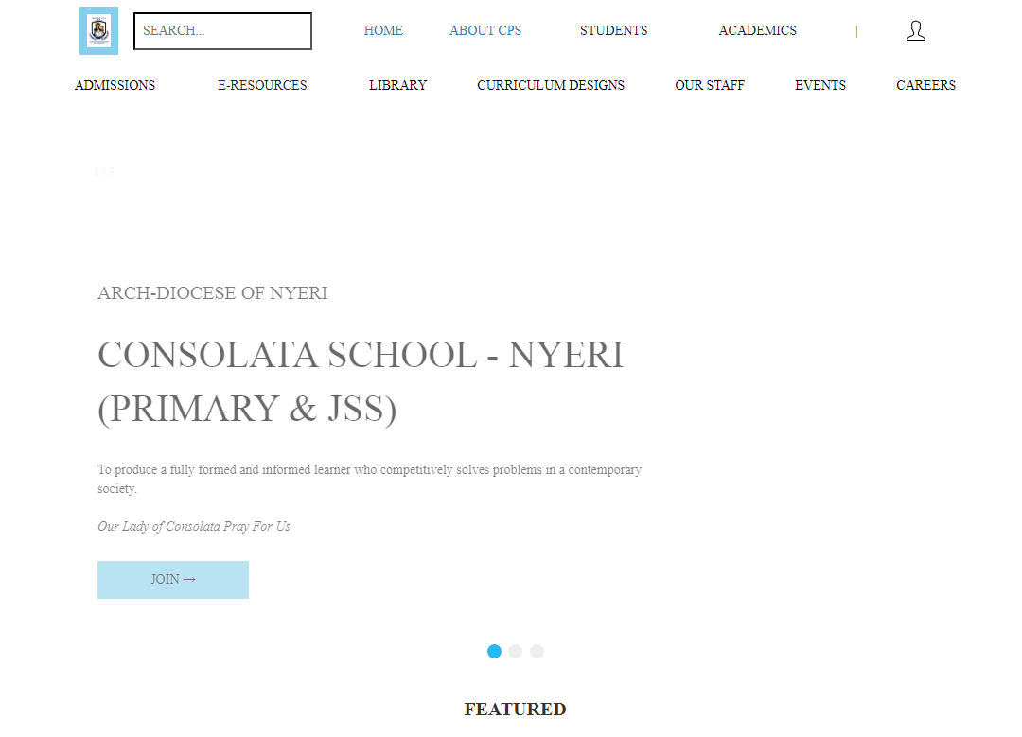

Figure 1.1: Consolata School Website Landing Page

Once on the landing page, the website will present you with several types of content.

These include:

1. Navigation Panel.
2. Quick Links.
3. Contacts

### 1.3 The Navigation Panel

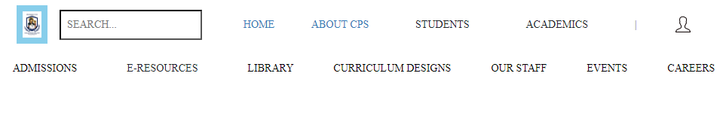

Figure 1.2: The Navigation Panel

The Navigation Panel provides you with links to most of the website’s web pages and content. The navigation panel contains the following links:

1. Home Logo
2. Search.
3. Home button.
4. About CPS.
5. Students.
6. Academics.
7. Login/Sign up.
8. Admissions.
9. E-Resources.
10. Library.
11. Curriculum Designs.
12. Our Staff.
13. Events.
14. Careers.

#### 1.3.1. The Home Logo.

The Home Logo is a link that gets you back to the landing page. It is located on every page. It works the same as a Home Button.

#### 1.3.2. The Search.

The search allows you to type whatever you want to search or find on any page of the website. To search:

1. Click on the Search box.
2. The insertion point appears.
3. Type in what you would like to look for.

#### 1.3.3. Home Button.

When clicked:

1. You are returned to home page.
2. If on the homepage, the page reloads.

#### 1.3.4. About CPS

The about CPS button navigates you to the “About Us” page. Here you will find items such as:

1. School Administrators
2. School Motto
3. School Mission
4. School Vision.
5. School Values

#### 1.3.5: The Students Button

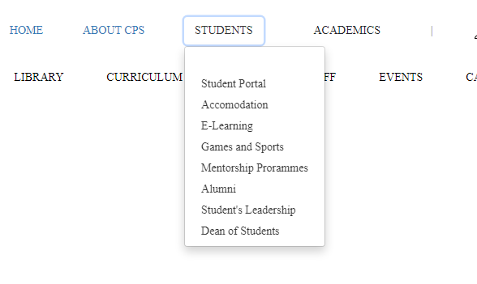

**Figure 1.3: Student Button List.**

The student button contains the following links. They include:

1. Student portal.
2. Accomodation.
3. E-Learning.
4. Games & Sports.
5. Mentroship programme.
6. Alumni.
7. Student Leadership.
8. Dean of Students.

**1.3.5.1.: The Student Portal**

The student portal button links to the student portal and dashboard. The dashboard or portal is a student’s space containing personal information, and specific information concerning the a learner.

**NB**: This system functionality is absent in the current version.

**1.3.5.2: Accomodation**

The accomodation button links to the student portal – Accomodation section. Each learner’s portal or dashboard will have an accomodation section, whether day or boarding. However this section will only be active for boarding learners only. The accomodation contains dormitory names assigned, matrons or patrons assigned, account balances, and any other requirement.

**NB**: This system functionality is absent in the current version.

**1.3.5.3: E-Learning**

The E-Learning button links to the student portal – E- Learning section. The E-Learning is a versatile system built whose primary function is currently to offer assignments, notes and exam revision materials.

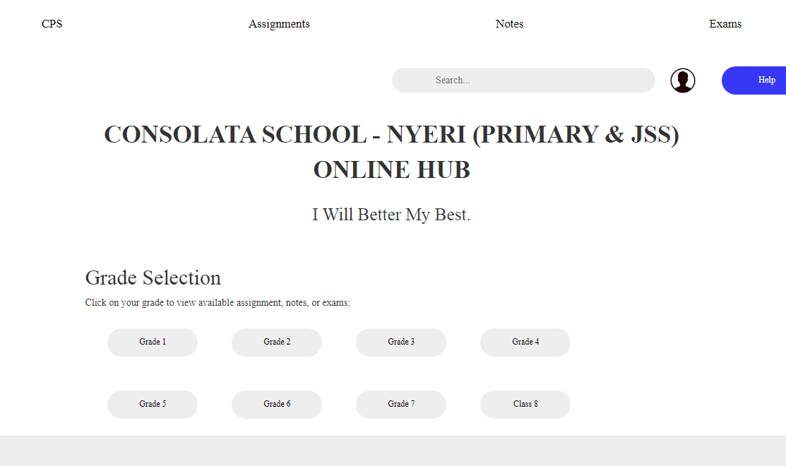

Figure 1.4 : E-Learning system.

**1.3.5.4: Games & Sports**

The Games & Sports button links to co-curricular activities of the institutions. These include all types of games and sports. The page comprises of past and upcoming events. Also, there are images and videos of events.

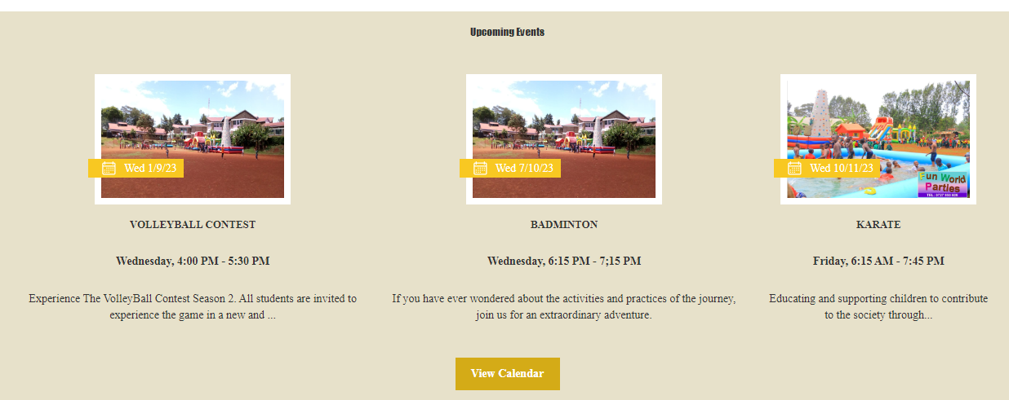

Figure 1.5: Games and Sports page.

**1.3.5.5: Mentorship Programmes**

The Mentorship programme button links to Mntorship page. The Mentorship page comprises a variety of mentors, and mentorship programmes and schedules in the school.

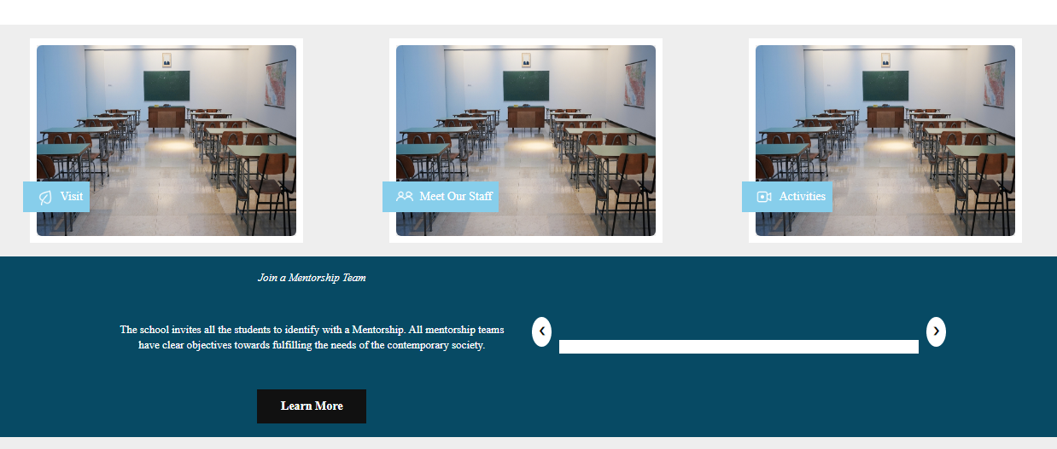

Figure 1.6: Mentorship page.

**1.3.5.6: Alumni**

The Alumni page contains student Alumni of the school since its first K.C.P.E. It also contains Teacher Alumni, and their portfolio.

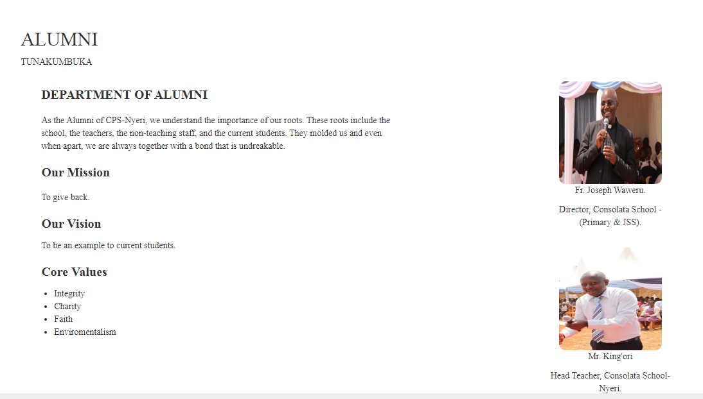

Figure 1.5: Alumni page.

**1.3.5.7: Student Leadership.**

The student leadership page links to a page with all the student leaders; basically the entire prefecture structure from Deputy Head Teacher to class prefects.

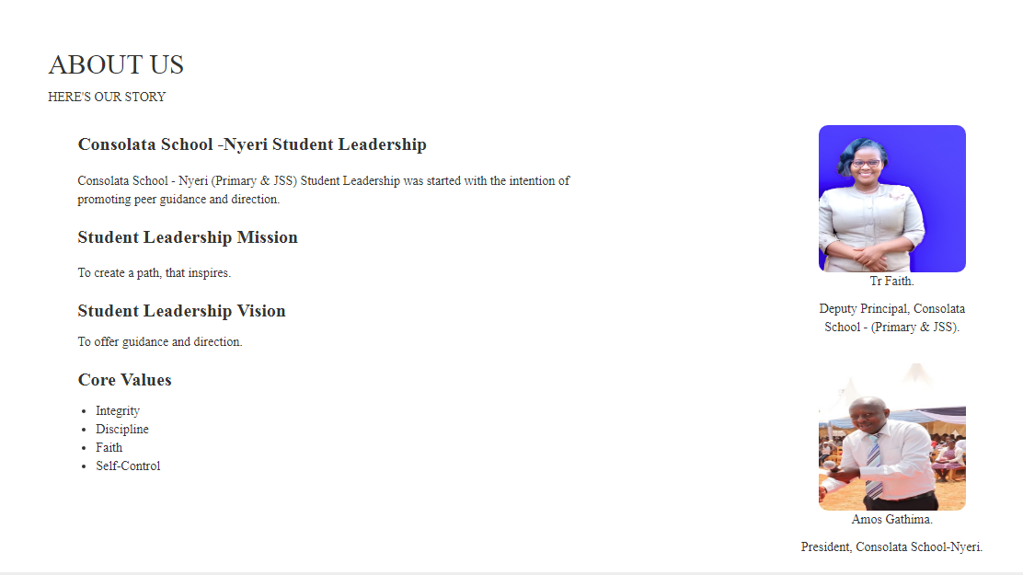

Figure 1.7: Student Leadership.

**1.3.5.8: Dean of Students**

The Dean of Students button links to a page with the two Deans of Students for Primary and Junior Secondary Schools. The page contains information regarding the departments, the mission, vision and values.

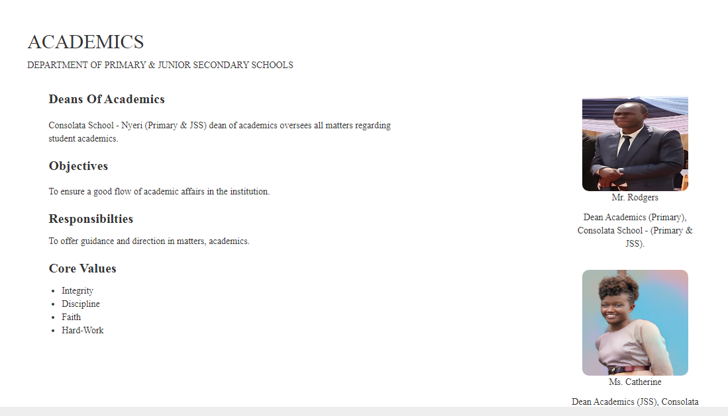

Figure 1.8: Deans of Students.

#### 1.3.6. Academics

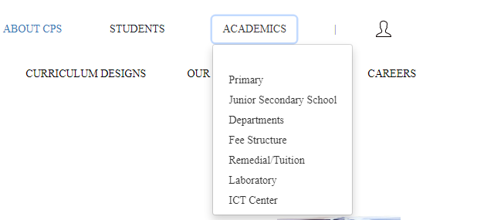

Figure 1.9: Academics Button List.

The Academics button contains the following links:

1. Primary.
2. Junior Secondary.
3. Departments.
4. Fee Structure.
5. Remedial Tuition.
6. Laboratory.
7. ICT Center.

**1.3.6.1: The Primary**

The primary button links to the primary section page. The primary section has information about the institution’s primary section, including primary levels such as lower, middle and upper primaries. Moreover, it has the dean, the mission, vision, and values for the same.

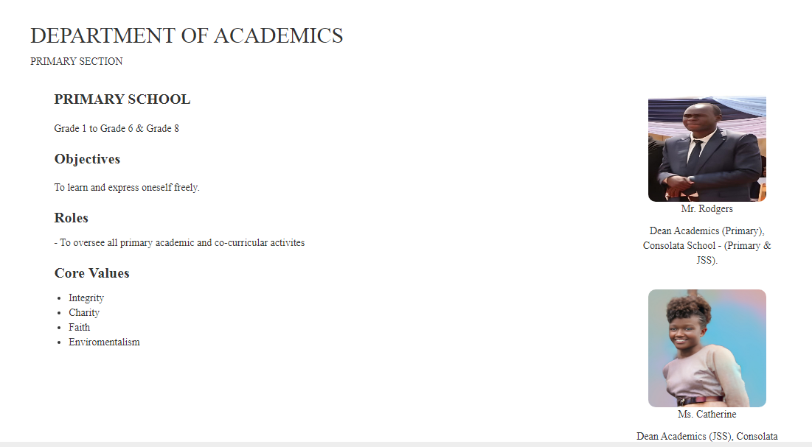

Figure 1.10: Primary Section.

**1.3.6.2: The Junior Secondary School section.**

The Junior secondary school button links to the JSS section page. The Junior secondary school section has information about the institution’s JSS section, including JSS levels such as Grade 7, Grade 8, and Grade 9. Moreover, it has the dean, the mission, vision, and values for the same.

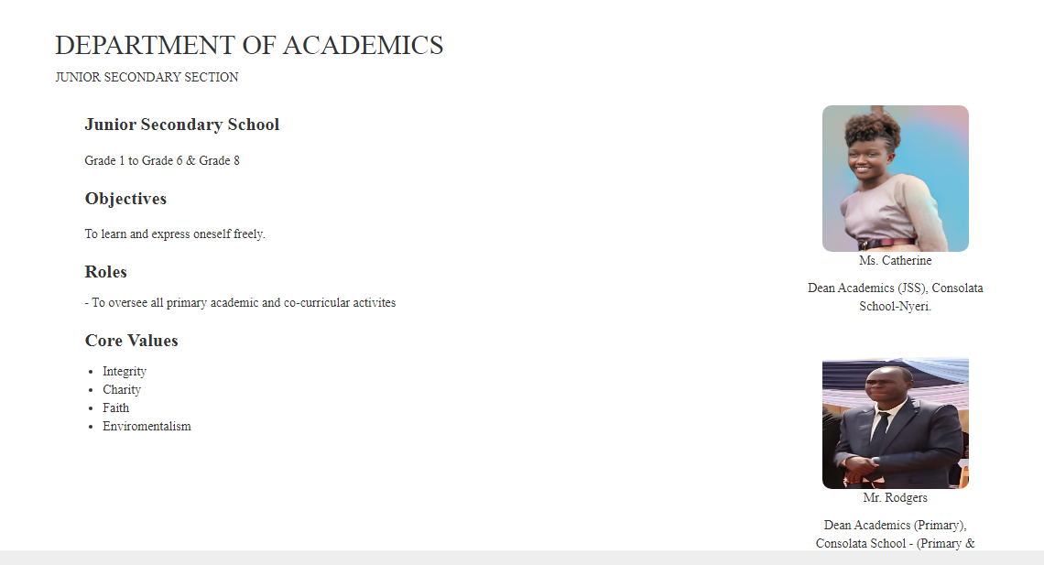

Figure 1.11: The JSS section

**1.3.6.3: The Departments.**

The departments button links to departments page. The page hosts all school departments including academics, languages, clubs and societies, mentorship, alumni, etc.

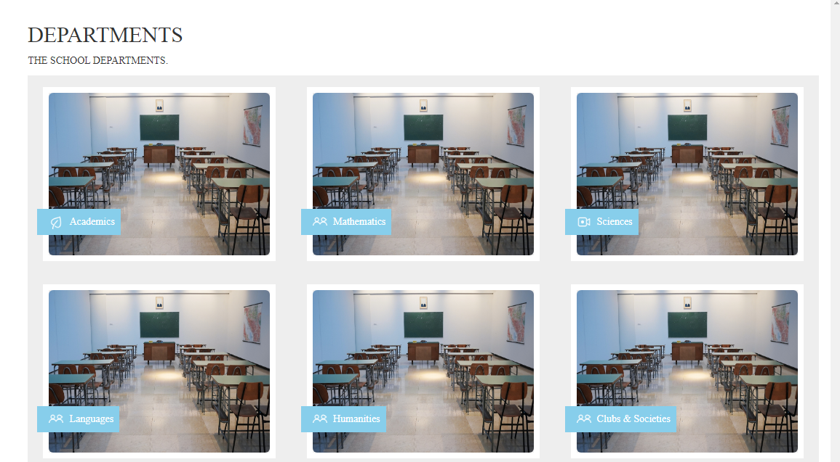

Figure 1.12: School Departments.

**1.3.6.4: The Fee Structure**

The Fee structure button links to the admissions page. The page hosts several academics components, including fee structures for primary (Day & Boarding), and Junior Secondary School (Day & Boarding).

To get a copy of the fee structure:

1. Get a hardcopy from the school’s secretary’s office from 9:00 A.M to 5:00 PM.

Or,

1. Get an online copy from our website. To download one,
2. On the Navigation bar, go to “Academics”, and select “Fee structure”.
3. On the “Department of Academics” page, scroll to either fee structure for primary or JSS.
4. Click on the “Fee Structure” .

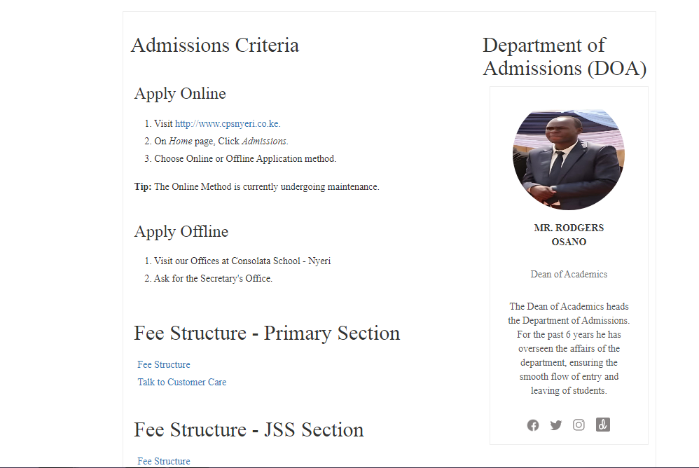

Figure 1.13: Fee Structure.

**1.3.6.5: Remedial & Tuition**

The remedial and tuition button links to the E-Learning center.

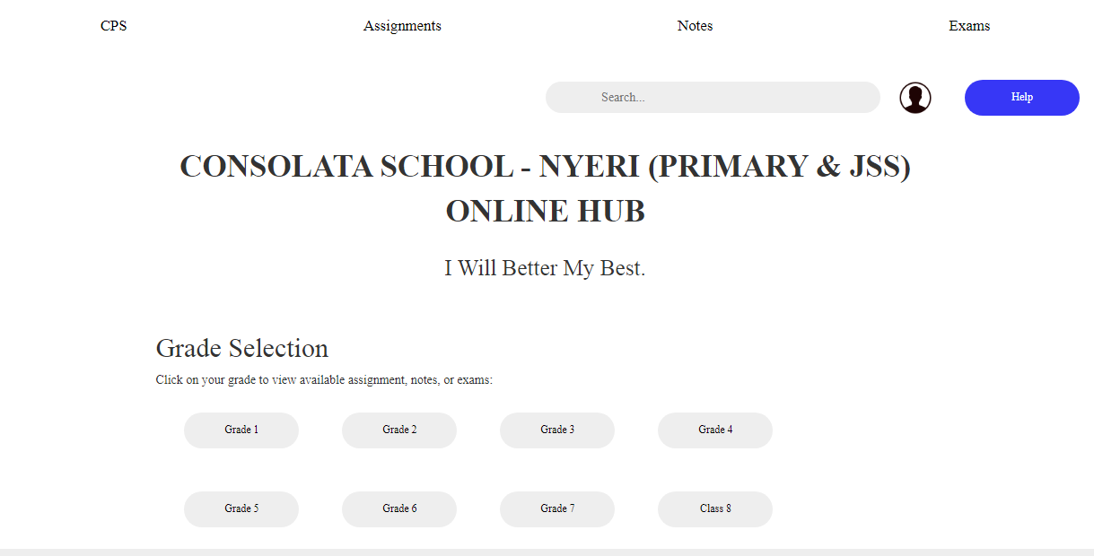

Figure 1.14: Remedial & Tuition center.

**1,3,6,6: The Laboratory Button**

The laboratory button links to the science laboratory page. On the science laboratory page, there is a link to the computer or ICT laboratory. The page contains information regarding the laboratory such as laboratory technician (s), images, learning videos, latest experiments, etc.

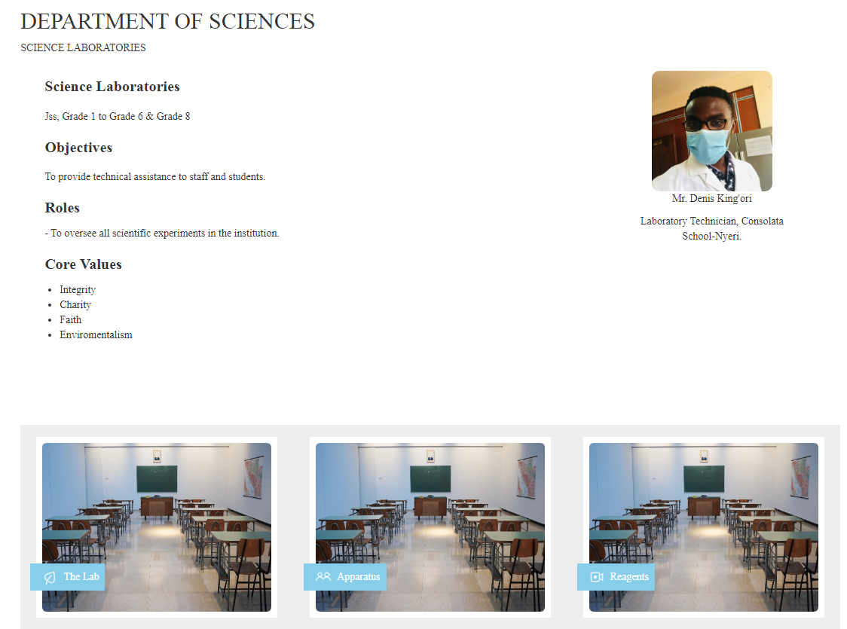

Figure 1.15: The science laboratory page.

**1.3.6.7: The ICT Center button**

The ICT Center button links to the ICT laboratory. The page contains information regarding the laboratory such as laboratory technician (s), images, learning videos, latest practicals, etc.

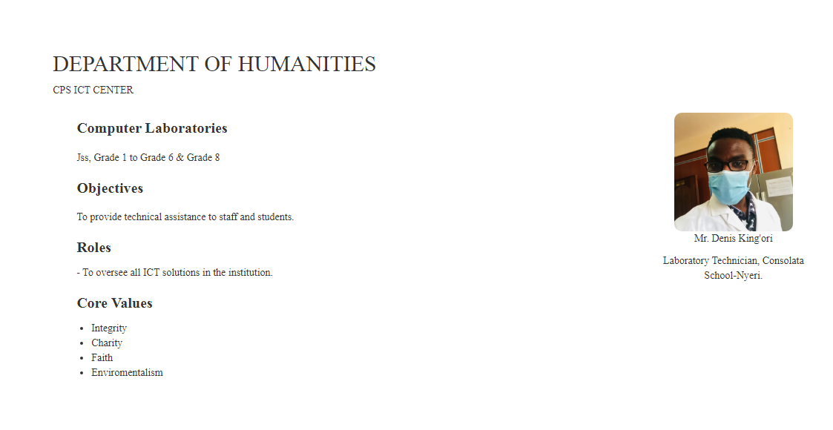

Figure 1.16: The ICT center laboratory page.

#### 1.3.7: Sign Up & Login Button

The sign up and login button links to students and staff login and sign up pages respectively.

To login:

1. Hover over the login icon.
2. Select Login

To Register/Sign up:

1. Hover over the login icon.
2. Select Create Account.

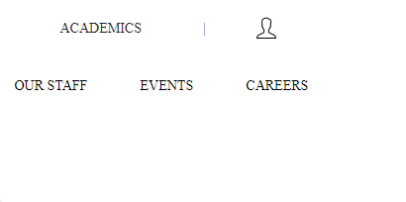

Figure 1.17: Login & Sign up button

#### 1.3.8: Admission

The admission button links to the department of academics, admission section. The page contains admission requirements, department heads, and a means for downloading the same.

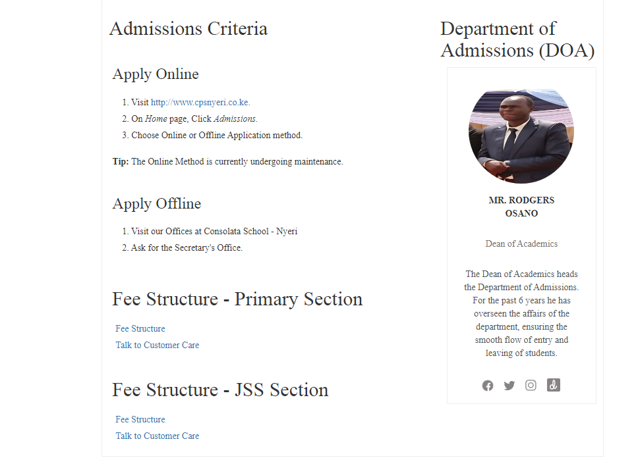

Figure 1.18: Admissions page

#### 1.3.9: The E-Learning button

**The E-Learning button contains the following links:**

1. Student portal
2. Online Support.
3. E-Learning.
4. Student Email.
5. Accommodation Application
6. CPS Wi-Fi
7. Online Books & Journals

**1.3.9.1: The Student Portal**

The student portal button links to the student portal and dashboard. The dashboard or portal is a student’s space containing personal information, and specific information concerning the a learner.

**NB**: This system functionality is absent in the current version.

**1.3.9.2: The Online Support.**

The online support button links to several online support mediums. These include:

1. A contact page

User shall fill in their personal information, including name or email, contact and query.

1. Call

This medium redirects the user to a caller application, enabling the user to make a phone call to a predefined support phone number.

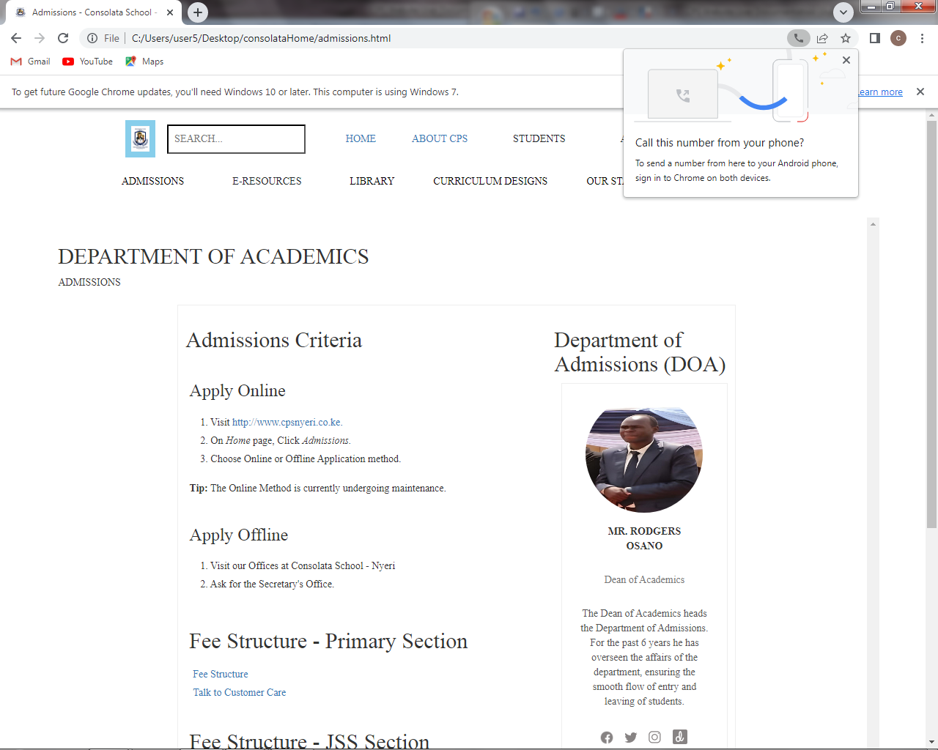

Figure 1.19: Contact caller dialog box

**1.3.9.3: E-Learning.**

The E-Learning button links to the student portal – E- Learning section. The E-Learning is a versatile system built whose primary function is currently to offer assignments, notes and exam revision materials.



Figure 1.20: E-Learning system.

**1.3.9.4: The Student Email**

The student email button links to student email creation system. In the page, or panel, students are allowed to:

1. Create at least one corporate email,
2. View or change passwords
3. Access email, and
4. Get email settings for other devices.

NB: This function is currently not supported by the current system version.

**1.3.9.5: Accommodation Application**

The accommodation application button links to the accommodation department page. The page contains:

1. Heads of department
2. Patrons
3. Matrons
4. Mission
5. Vision
6. Values

**1.3.9.6: CPS Wi-Fi**

The CPS-Wi-Fi button links to ICT Center, where Wi-Fi, among other connection and file sharing services are accessed. On the page, Communication and Networks section, students, staff and authorized personnel are allowed to:

1. Create an alias name
2. Create password
3. Edit or change password or alias names,
4. Troubleshoot connection problems
5. Access FAQ’s

**1.3.9.7: Online Books & Journals**

The online books and journals button links to the Online Library. The Online Library has the following features:

1. Access to all grades notes.
2. Access to examinations revision materials.
3. Access to assignments.

#### 1.3.10: Library

The library button links to the Online Library. The Online Library has the following features:

1. Access to all grades notes.
2. Access to examinations revision materials.
3. Access to assignments.

#### 1.3.11: Curriculum Designs

The curriculum design button when clicked opens the curriculum designs page. While on the page:

1. Select a subject.
2. Select a grade;
3. Double click on any document of interest to open on a new browser tab.

#### 1.3.12: Our Staff

The our staff button links to the staff page. To become a staff in the institution:

1. Click join.
2. Follow the steps of job Application.

On this page, there are:

1. Administrative staff,
2. Teaching Staff, and
3. Subordinate staff.

Their profile pictures, short bio, and social media handles.

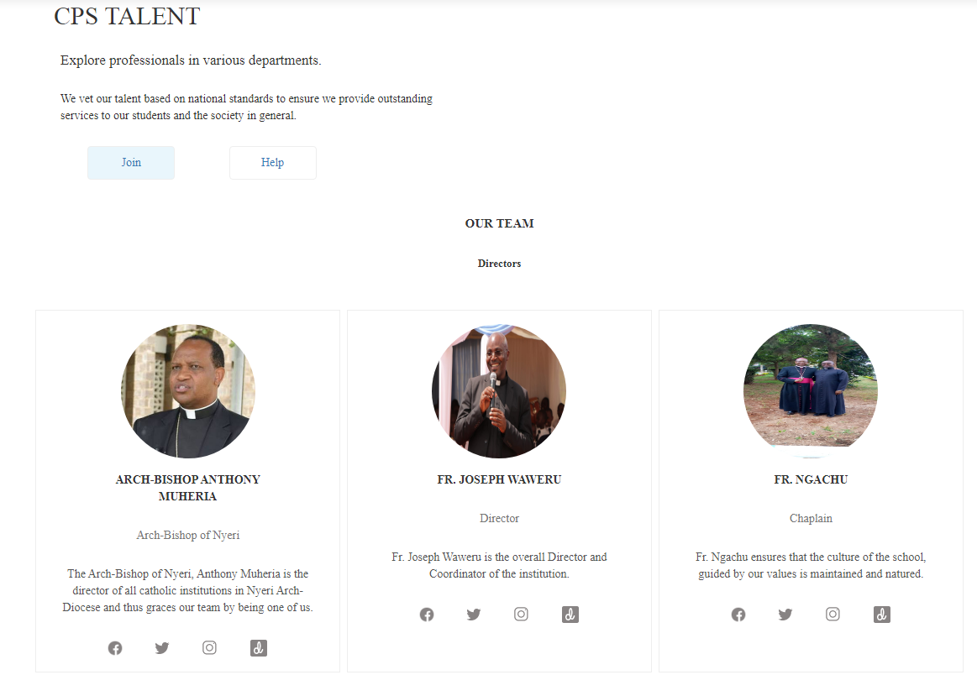

Figure 1:21: Staff & Job Application page,

#### 1.3.13: Events

The events button links to the events page. The events page has the following:

1. Past events
2. Current events
3. Future or upcoming events

The events are in form of text, images and videos.

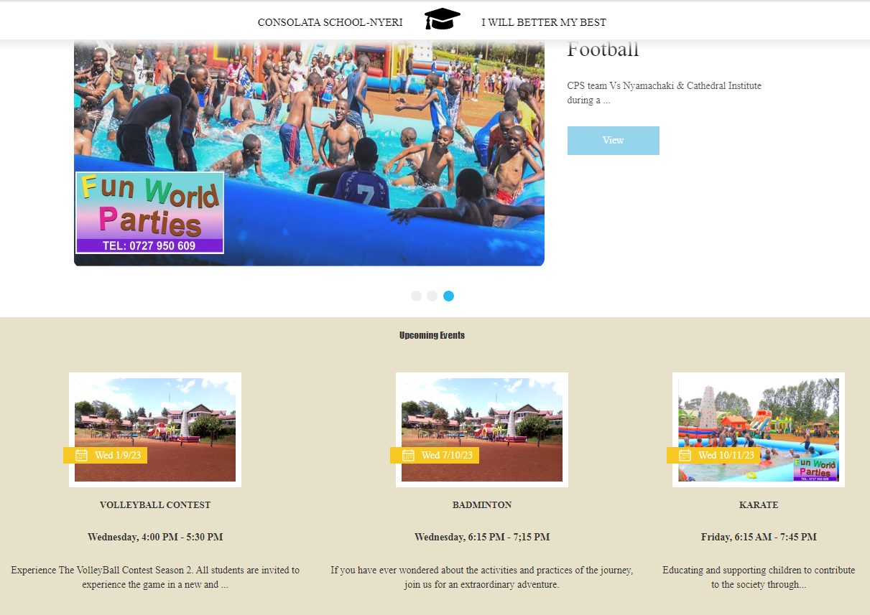

Figure 1.22: Events page

#### 1.3.14: Careers

The careers button links to the careers page. On this page, one may:

1. View current job vacancies
2. View past job vacancies
3. View standard job requirements for teachers and non-teaching staff.
4. Career guidelines and advice.
5. Job application procedures.
6. Job application system.

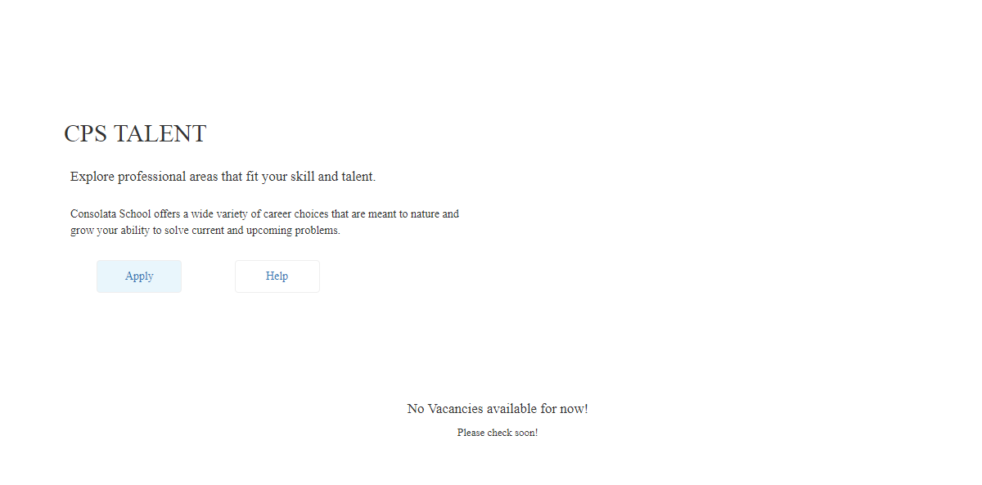

Figure 1:24: Careers page

### 

### How To

Register

On the navigation panel, hover on the register or login icon on the far right. On hover, select “Create Account”.



Figure 1:25: Login/Register actions

On the “Create Account” page:

1. Select “Learner” or “Satff”
2. Enter First Name
3. Enter Surname
4. Enter Username
5. Enter Password
6. Confirm Password
7. Agree to Terms and Conditions
8. Click the “Welcome” button to register.

Login

On the navigation panel, hover on the register or login icon on the far right. On hover, select “Login”.

On the “Create Account” page:

1. Select “Learner” or “Satff”
2. Enter Username
3. Enter Password
4. Click the “Login” button to Login.